17.9.18

FAO: Year 6 Parents

Dear Parents/Guardians,

Welcome back to Year 6. I hope you have had a fantastic summer and made the most of the weather while it lasted.

In Year 6, we will be celebrating the centenary of the end of the First World War as our topic and much of our English writing sessions will focus on different aspects of this event. We will be doing this alongside daily Maths sessions and weekly Science, RE and PE sessions.

Science: This term we will be covering the subject of Light. We will be exploring how light travels; refraction and the spectrum of white light; shadows and how we can design experiments to test out our theories.

RE: This term Year 6 will be learning about Islam with Mrs Clarke.

PE: For the first half term, we will be going swimming every Tuesday afternoon at Wadebridge Swimming Pool. The aim of these sessions is to ensure that every pupil leaves Padstow being able to swim 25m independently. If your child is already a confident swimmer, a professional coach will extend stamina and improve their technique with focused coaching sessions. All instructors are fully qualified and experienced in delivering Swimming sessions to Primary aged pupils. Please ensure your child has their kit and it is clearly labelled

Maths: This term we will be focusing on Place Value before moving on to the four operations. Alongside this, we will be completing daily arithmetic sessions and having weekly arithmetic tests to start preparing us for next May’s SATs.

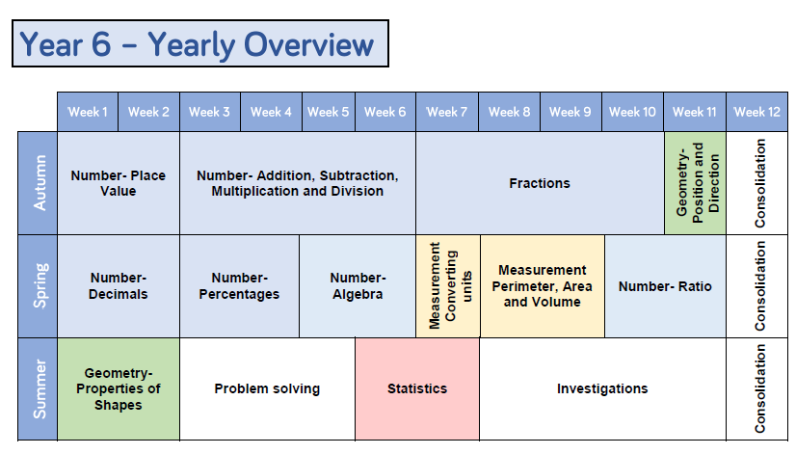

English: Up to half term, our English units will include Diary writing, Non – chronological reports and WW1 inspired poetry.

Spelling: Each week we will be having weekly spelling tests to help the pupils consolidate their learning of the statutory word list and the core spelling rules as set out in the national curriculum. As the SATs assessment includes words from both the Year 3 / 4 and the Year 5/6 Spellings Lists all Year 6 pupils will be expected to learn given words from each list.

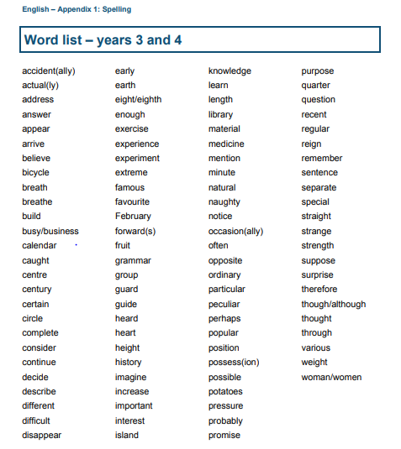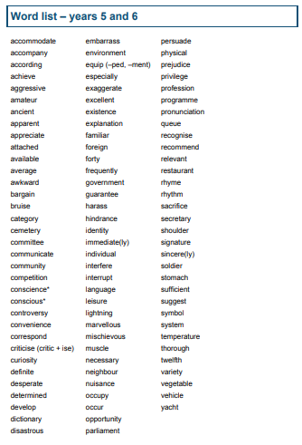

Homework:
In this first term, there will be a weekly Maths Homework that will complement the topic we are focusing on in class that week. It is important that children complete this homework regularly as it not only reinforces their current learning but also prepares them for the rigours of moving on to Secondary School. After Christmas, as we move closer to the SATS Assessments there will be Grammar and reading homework as well.

Maths Club:
From Tuesday the 18th of September, Mr Anderson will be running a weekly invitation Maths club to support the pupils in understanding the key mathematical concepts. If your child has not been invited, but you would like them to attend, please contact Mrs Brooks in the office to request a permission slip.

How you can help your child in Year 6:

Reading
-Reading with your child four times a week and asking them questions to check their understanding is hugely beneficial. These questions can involve retrieval of information or inference to identify things such as character feelings or authorial intent.
Spelling:
Regular practise of spelling is proven to one of the most impactful ways of improving a child is spelling. This does not have to mean writing them repeatedly but could involve verbal games and inventing funny mnemonics to improve memory retention.

Maths: While all help with maths homework is greatly appreciated, we understand that this can be difficult due to the demands of work and other commitments but giving your children access to any form of mathematical experience, such as handling money, reading timetables or measuring, can be incredibly beneficial to their understanding of the key mathematical concepts.

Other Information: We encourage your child to have water bottles in school so they have access to water throughout the day. Snacks from home need to be labelled and put in the snack trolley for break time. Please can you help us with our Healthy School status and provide fruit, veg or other healthy snack.
If you have any questions please do not hesitate to come and ask me – either quickly at the door, first thing in the morning or should you need longer, make an appointment at the office to see me after school.
Yours sincerely,
Mr. Gus Anderson

