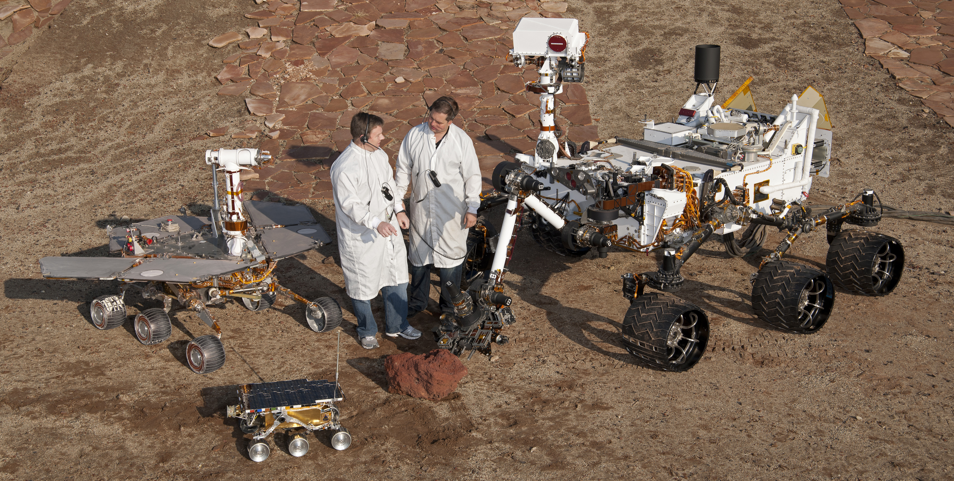
Year 5 Spring 2019

Homework for this half

term is to create a
planetary rover.
Your rover needs to be designed to:

- Take samples on the planet
- Move itself around
- Send signals back to Earth

Think about which planet in our solar system you will send the rover and the adaptations it will need to survive on your chosen planet. Homework projects need to be completed and in school by Monday 1st April.

Mr Emery

