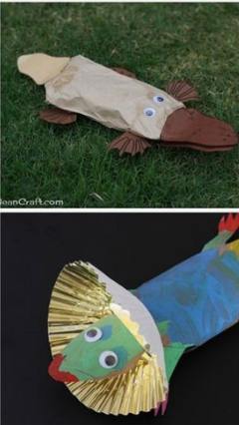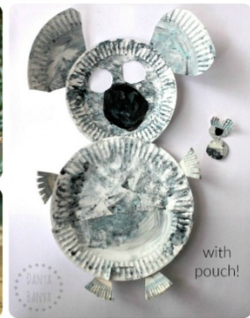

For this terms homework we would like you to design and make an animal or sea creature that lives in Australia.

You could simply draw/paint a picture or show off your creativity and make a 3D model of your chosen animal. Make it as colourful and imaginative as you can. You can use any materials you like cardboard, food, clay, pebbles, recyclable materials etc.

Year 2 Australia Homework

**Homework due in Monday 17th December ready to displayed in assembly that week.**

**Challenge: If you would like a challenge then you could find out 5 facts about your Australian animal which can be displayed with your creation in the assembly hall.**

