**01.03.2018**

**FAO: Year 6 Parents**

Dear Parents/Guardians,

Welcome back to Year 6. I hope you have had a fantastic half term and made the most of the pleasantly unseasonable weather. I hope that that will not be our summer.

This half term we will be continuing with our topic of World War 2 while continuing our preparation for the SATs exams that are due to take place in the middle of May. We will continue to do daily: Maths, English and Spellings alongside weekly sessions of PE, RE and Science.

In addition to high quality whole class teaching, myself and the Year 6 team will also be undertaking some Maths, Reading and Grammar intervention sessions in the afternoons to fill any gaps and misconceptions the children may hold.

**Science:** This term we will be covering ‘Evolution and Inheritance’. This will involve looking at what characteristics are inherited and which are acquired and what part this has played in the theory of evolution.

**RE:** This term Year 6 will be learning ‘Christian ways of Living’ with Mrs Clarke.

**PE:** This term we will continue to get outside whenever possible and will be focusing on Tag Rugby. We will be encouraging everyone to get involved and try their hand at what may be a new sport to some pupils. We will be learning the rules as well as some of the key features of this unique sport such as ball handing, defending and timing.

**Maths:** This term we will be focusing on measurement and building on the pupil’s previous learning from Year 5. This learning will involve converting and calculating units of measure (both metric and imperial) and will also involve using measurement for practical uses such as perimeter, area and volume. Before Easter, we will turn our attentions to ratio and proportion.

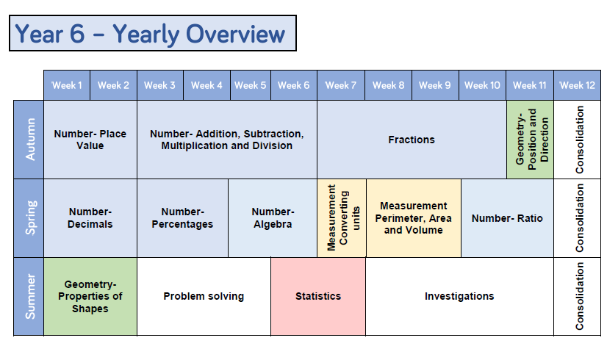

**English:** This half term we will be writing and performing a persuasive speech as well as re-visiting narrative writing using The Minpins by Roald Dahl.

**Spelling:** Each week we will be having weekly spelling tests to help the pupils consolidate their learning of the statutory word list and the core spelling rules as set out in the national curriculum. As the SATs assessment includes words from both the Year 3 / 4 and the Year 5/6 Spellings Lists all Year 6 pupils will be expected to learn given words from each list.

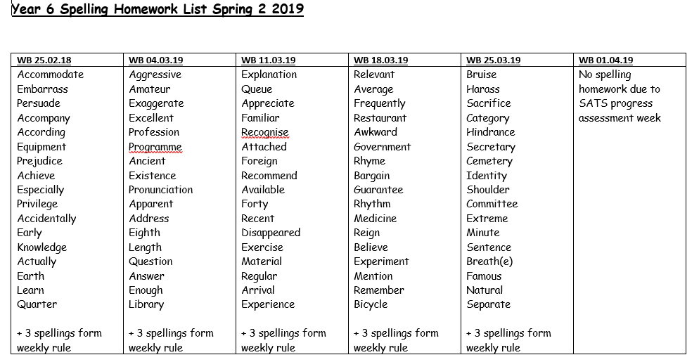

We will also be doing a full assessment of each child’s gaps and this will be sent home with the child so that they can practise their individual spelling requirements at home independently.

**Homework:**

Reading: x 4 times per week.

Spellings: Weekly list (see below)

Maths: Weekly homework recapping class content

Grammar: Weekly homework

Reading Comprehension: Weekly homework

**Maths Club:**

Mr Anderson will continue to run a weekly Maths club to support the pupils in understanding the key mathematical concepts. All pupils are welcome. If your child does not currently attend but would like to, please visit Mrs Brooks in the office for a form.

**How you can help your child in Year 6:**

**Reading**

-Reading with your child four times a week and asking them questions to check their understanding is hugely beneficial. These questions can involve retrieval of information or inference to identify things such as character feelings or authorial intent.

**Spelling:**

Regular practise of spelling is proven to one of the most impactful ways of improving a child is spelling. This does not have to mean writing them repeatedly but could involve verbal games and inventing funny mnemonics to improve memory retention.

**Maths:** While all help with maths homework is greatly appreciated, we understand that this can be difficult due to the demands of work and other commitments but giving your children access to any form of mathematical experience, such as handling money, reading timetables or measuring, can be incredibly beneficial to their understanding of the key mathematical concepts.

**Other Information:** We encourage your child to have water bottles in school so they have access to water throughout the day. Snacks from home need to be labelled and put in the snack trolley for break time. Please can you help us with our Healthy School status and provide fruit, veg or other healthy snack.

If you have any questions please do not hesitate to come and ask me – either quickly at the door, first thing in the morning or should you need longer, make an appointment at the office to see me after school.

Yours sincerely,

Mr. Gus Anderson