ATTENDANCE MATTERS
IN SCHOOL. ALL DAY. EVERY DAY.
JANUARY 2019

Welcome to our Autumn Term 2018 Attendance Newsletter. At Padstow, we are committed to ensuring that each and every child in our school fulfils their potential. To help us achieve this, we need all of our children to have the best possible attendance.

Our Attendance Target this year is 96%

Why does every day and every minute count?

Attending school every day gives your child the opportunity to make friends and feel included, increases their confidence and self-esteem, improves their social skills and allows them to achieve their full potential.

Your child’s absence is closely monitored by the school and Aspire. Ofsted, on every visit, will request an up to date attendance analysis. When your child’s attendance falls below the national expectation, you will receive a letter from the school and may be asked to attend a meeting with the Head of School. If your child’s attendance does not improve you may be asked to meet with the school and the Attendance Welfare Adviser.

Attendance – 4th September to 18th December 2018
Reception:  90.82% | Year 1:  93.44% | Year 2:  91.63% | Year 3:  93.35% |  | Year 4:  91.46% | Year 5:  95.1% | Year 6:  93.05%
Average School Attendance: |  |  |  | 92.72%

We recognise that this term we have had a nasty bout of gastroenteritis which has required you to keep your child at home for 48 hours. This has had an impact on some children’s attendance percentage – please do not worry about this as we understand children had to be kept home.

Unauthorised absences account for 2.21% across the school.

What if I want to go on holiday?

Holidays during term time are not authorised in line with Government guidelines. If leave of absence is required e.g. a close family bereavement or other exceptional circumstances, you will need to complete a form which is available from the school office. The Head of School will then consider whether the absence will be authorised or not. Holiday during term time will not be authorised.

WHY BE IN SCHOOL ON TIME?

Punctuality is also just as important as attendance. Here at Padstow, registers are taken at 8:50am so that lessons can start promptly at 9:00am. It is important that children arrive in school on time as it supports them to learn good timekeeping and reduces classroom disruption for the other children and themselves.

It is very important to ensure your child starts the day calmly to ensure they don’t miss vital parts of lessons. We start teaching at 9:00am every morning. Arriving after 9:00am, a child misses the start of a lesson. Arriving after 10:00am, means a child will have missed their Read Write Inc lesson in KS1 and a complete Maths or English lesson in KS2. Children also feel embarrassed at having to enter the classroom late.

School finishes at 3.15pm. Children should be collected on time. Please inform the school if you wish for someone else to collect them. The office will then record this and let the classroom teacher know the change to the usual arrangements.

If your child is in Years 4, 5 and 6, and you are happy for them to walk home, the school must have a letter from you giving permission for this to happen.

What can I do to help improve my child’s attendance?

- Avoid routine appointments during school times unless it is urgent.
- You can help by bringing your child in school after or before the appointment as long as you inform the office.
- Make an appointment to speak to either the Head of School or the Pastoral Lead.

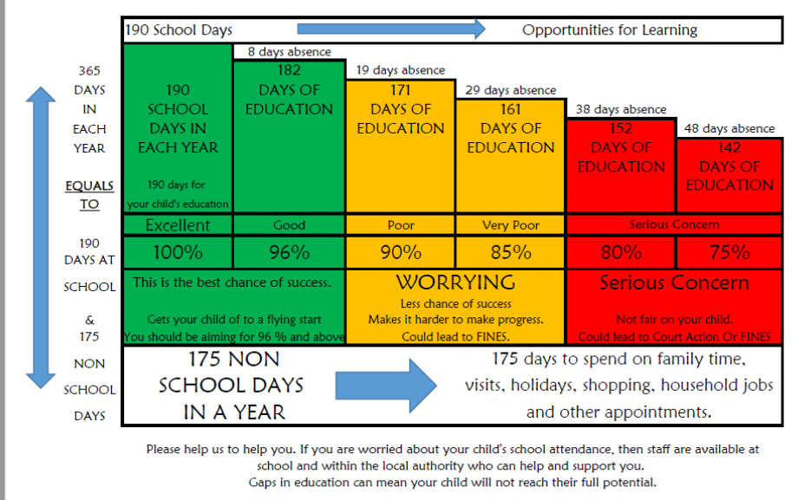
Please visit our website: www.padstowschool.org for further information in our parents leaflet.

