Personal Social and Emotional Development  We will share the story Owl Babies and talk about how the babies feel during different parts of the story.  We will take part in circle times sharing our thoughts and ideas with our friends, taking turns to talk and listen to each other. | Key Questions  • What happens when you fall asleep?  • Have you ever seen the Moon?  • How many stars are in the sky?  • Where does the Sun go at night?  • What is a star?  • Do you know the name of any planets?  • Do you know the name of any constellations?  • What does it feel like when you look at the stars?  • Are the stars still there in the day?  • What do you do at bedtime? | Physical Development  We will be taking part in Write Dance to improve our gross and fine motor skills.  We will be working on our scissor control and how to hold our scissors correctly when cutting.  We will be focusing on holding our pencils correctly and forming our letters correctly.  We will make split pin astronauts | Communication and Language  We will have class discussions about the topic questions and stories we have shared.  We will share our holiday news thinking carefully about how we speak in a whole group situation and how we make good listeners.  We will design our own planets and aliens and describe what they are like.  We will learn key vocabulary for the topic.
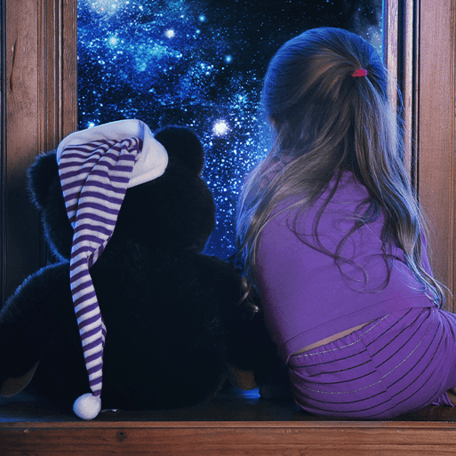
PUFFINS SPRING TERM 1 2020
WHAT HAPPENS WHEN I FALL ASLEEP?
We will find out about the moon, stars, sun and planets, nocturnal animals, people who work at night and why sleep and rest are important.
Literacy  There will be a range of fiction and non-fiction books about space and night in the reading area.  We will share a range of night based stories and non-fiction texts as a class.  Handwriting- we will be focusing on anti clockwise letters (c, o, a, d, g, q, e, s)  We will write labels thinking carefully about the sounds we can hear.  We will learn to write simple captions using finger spaces in between our words.  We will focus on reading and writing the red words - I, the, my, put, to, be, of and you. |  |  | Mathematics  We will focus on forming our numbers correctly.  We will look at one more and one less than a given number.  We will focus on addition and subtraction number sentences and the vocabulary used.  We will compare and order objects and pictures by size thinking carefully about the language we use such as bigger, biggest, smaller, smallest.
 | Expressive Arts and Design  We can act out the story of Whatever Next!  We will make mobile stars to hang up in the classroom.  We will design our own space/alien creatures thinking carefully about what materials we will use.  We will make our own lolly stick puppets and space scenes to tell our own stories.  We will learn how to paint pictures thinking about how to hold a paintbrush and the size of things we paint. | Understanding the World  Why is it dark at night? We will explore what happens when light isn’t present.  Look at the similarities and differences of night and day and the similarities and differences of the moon and planets compared to Earth.  We will learn about nocturnal animals and how they find food in the night.  We will learn about people who work at night and what jobs they do.

