THE VIKINGS HOMEWORK - due 13th December 2021

Homework to be brought into school on 13th December 2021 for the: Homework project celebration assembly. | ICT/Art/English  Draw or print out a picture of yourself and a Viking child. Write about the similarities and differences between you both. Include information about their day, school, family, toys, pets, work. | DT  Design a Viking board game.  How many players can play? What is the purpose of the game and how do you win? | Art  Select a famous figure from the Anglo-Saxon or Viking era. Draw or paint or collage a picture of them. It could be a king, soldier, God or someone else.
DT  Build an Anglo-Saxon or Viking home. Think about the features of the home and write how it is different to our homes now. | RE/History  Research what the Vikings thought about death. Where do they believe they go when they die? What rituals did they practice? | DT/Food  Design a Viking meal. It could be fun to have a go at making a recipe or two!! Take pictures of you making it or bring some into school for us to taste.  (Take photos etc to bring into school) | History/English  Research the Yorvik centre in York.  Write key information about it.
Art  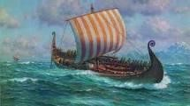  Create an interesting collage of a Viking scene; stormy sea, long boat, a raid! | DT  Make a model of a Viking long house or a Viking long boat.  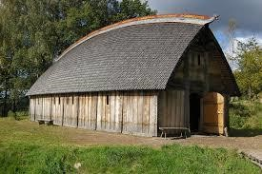 | English  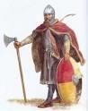  Write a diary entry for a Viking warrior or an Anglo-Saxon settler. How would a diary entry be written long ago? | English  Write a fact file about Viking travel or lifestyle.

