Personal Social and Emotional Development  We will talk about the characters in the story, discuss if they are good or bad and how they should have behaved or acted.  We will take part in circle times sharing our thoughts and ideas with our friends, taking turns to talk and listen to each other. | Key Questions  • Which was your favourite part of the story?  • Which characters can you remember?  • Which characters were good? Which were bad?  • Do you know the names of characters from other fairy tales?  • Which is your favourite fairy tale?  • Which character would you like to be? | Physical Development  We will be taking part in team games during our P.E. sessions.  We will be working on our scissor control and how to hold our scissors correctly when cutting.  We will be focusing on holding our pencils correctly and forming our letters correctly. | Communication and Language  We will have class discussions about our favourite stories and why we like them.  We will share our holiday news thinking carefully about how we speak in a whole group situation and how we make good listeners.  We will design our own fairy tale characters and describe what they are like.  We will discuss which characters are good and bad.
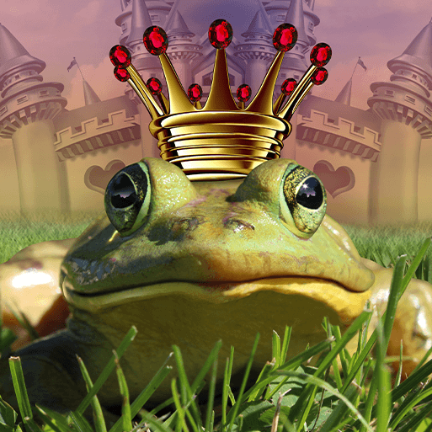
PUFFINS SPRING TERM 2 2020
Will You Read Me A Story?
We will throw ourselves into the land of fairy tales and stories, thinking carefully about the characters in them.
Literacy  There will be a focus on a range of traditional tales and new fairy tale stories.  We will write labels thinking carefully about the sounds we can hear.  We will learn to write simple sentences using finger spaces in between our words and full stops at the end of our sentences.  We will pretend to be a character from a story and write a letter from them. |  |  | Mathematics  We will focus on forming our numbers correctly.  We will learn about teens numbers to 20 and what numbers they are made up of using the part part whole model.  We will focus on addition and subtraction number sentences and the vocabulary used.  We will look at repeated patterns, how we can continue them and make our own.
 | Expressive Arts and Design  We can act out different traditional tales.  We will design and make our own fairy tale items such as crowns, wands, shields and castles.  We will make our own lolly stick puppets to tell our own stories.  Small world play. | Understanding the World  We will look at different materials and discuss which ones would be best for the 3 Little Pigs’ houses and why.  We will explore a range of beans and discuss similarities and differences.  We will design and make a bridge for the Billy Goats Gruff, thinking carefully about the materials we will use.

